Packages
Perfect for gifts, or as an essential treat for yourself.
The following packages are comprised of our most popular treatments.
HOLIDAY ESSENTIALS
½ leg wax
Bikini wax
Underarm wax
Eyelash tint
Brow shape
Gelleration pedicure
Finger file & paint
Value £97.00……………………..£79.00
TEENAGE ESSENTIALS
Discovery Facial
Eyelash Tint
Brow reshape
Toe File & Paint
Finger File & Paint
Value £68.50 …………………………..£58.00

COMPLETE INDULGENCE
Decleor Aromatherapy Body Massage
Decleor Vitamin Glow Facial
Luxury Thermal Spa Pedicure
Luxury Thermal Spa Manicure
Brow shape
Complimentary light lunch and wine
Approx value £160.00……………………..£130.00

TOP TO TOE
Decleor Vitamin Glow Facial
Jessica Classic Manicure
Mulberry Spa Pedicure
Brow shape
Value-£98…………………………….£.85.00

PARTY, PARTY!
Sienna X Spray Tan
Gelleration Gel Manicure
Eyelash Tint
Brow Reshape
Value £62.50 £58.00

WAXING
A quick and efficient way of temporarily removing unwanted hair. Lasts 3-6 weeks
Ankle to knee……………£17.00
¾ leg……………£20
Top of leg inc. bikini line £20
Full leg inc. bikini line…………£27
Bikini Line £ 12
Under Arm…………..£11
Arm…………………..£14.50
Lip Or Chin…………...£6.00
Lip & chin £8.50

EYE TREATMENTS
Eyebrow Threading……….£12 Lip Threading…………..£7.50
Eyelash Tint*………………………………………………….....£12.00
Eyebrow Shape………………………………..……….£10.00
Eyelash Tint & Eyebrow Shape *………………………..£16.50
Eyelash Tint, Eyebrow Shape & Tint*…………………………..£19.50
Eyebrow Shape & Tint*……………………………………………£13.50
*A patch test must be carried out at least 48 hours prior to this service, if you have not previously had tinting at this salon.

ELECTROLYSIS
Mulberry Salon uses the Sterex Blend method, for permanent hair removal. Gentle, effective and compatible even with the most sensitive of skins. We use a new, disposable Sterex needle for each treatment
10 mins………………………………………..£14
1 hr (6x10 mins)……………………………£70

AESTHETIC CLINICS

Sometimes a little help is needed! So with this in mind we are delighted to offer regular clinics covering various aesthetic procedures. Clinics held monthly, please ask for further information and advice.
SIMPLY AESTHETIC
Our fully qualified Nurse and Aesthetic practitioner Jess, has worked in this field for many years, and has been visiting Mulberry regularly for more than ten years.
Treatments include:
Fillers (i.e.- Restalyne) - used to soften lines, define lip border and increase lip volume.
Line Taming Injections (i.e. Botox) - for smoothing unwanted lines on the forehead, frown lines and crows feet.

DECLEOR AROMATHERAPY FACIAL TREATMENTS
A range of Decleor products are available for you to purchase and use at home, prolonging and enhancing the beneficial effects of your facial.
All Decleor treatments begin with a special back massage, designed to relax you and remove the pressures of your day.

ULTIMATE VITAMIN GLOW (all skin types) £43
Award winning Vitamin facial to leave your skin visibly radiant
This internationally renowned, multi-award winning facial is power packed with vitamins and anti-oxidants. Stress simply melts away thanks to a deeply relaxing massage and the ideal rebalancing elixir chosen for your complexion. Our deliciously warm and decongesting mask softly rehydrates your skin, leaving it deeply cleansed, perfectly replenished and glowing with vitality.
HYALURONIC ACID WRINKLE RESIST (1st signs of ageing 30+) £50
Utilizing powerful youth-boosting botanicals, this pampering facial intensively targets lines and wrinkles. The mineral loaded mask lifts, firms and plumps while a gentle exfoliation refines skins texture. Bringing immediate results, expression lines are smoothed ensuring skin looks luminous
COLLAGEN PLUMP & LIFT (anti-ageing 40 +) £50
Energizing but luxurious, specialized massage helps recharge skin tissues whilst an indulgent collagen rich thermo mask infuses the complexion with skin plumping nutrients. The skin’s natural renewal process is kick-started for a firmer, radiant skin.

ADVANCED SCULPT & LIFT (anti-ageing 50+) £50
Wrinkle correcting, radiance boosting and visibly plumping, our advanced solution to anti-ageing gives outstanding results. Concentrating on improving lines, loss of firmness, dryness and sensitivity. Rehydrating and strengthening the skin from within. A relaxing Sculpting Massage will focus on key areas - eyes, face , neck, decollete and shoulders.

HARMONIE CALM (sensitive skin)………………………………….£46
This intensely soothing treatment instantly relieves irritated complexions. Acting like a calming comfort blanket, Blueberry Extract soothes angry, sore skin; a cooling Algae plasticizing mask peels away to reveal a calmer, smoother surface. Redresses all types of sensitivity whether due to stress poor diet, illness, medication or simply fatigue. Skin becomes clear, soothed and more resilient to environmental aggressions.

DEVINE NUTRITION (dry, flaky skin)……………………………..£46
The end of dry, flaky skin, our ultra-nourishing facial deeply soothes, repairs and renews. Chestnut Extract boosts crucial lipid production and micro-circulation while nourishing Geranium and Rose feed skin with vital nutrients. By locking-in-moisture, complexions are also strengthened against wind, rain and cold; making it ideal for anyone who spends a lot of time outdoors. Even the driest complexions are left supremely supple, comfortable and satin smooth.

MOISTURE QUENCH (dehydrated skin)………………………£46
Super-hydrating and able to quench even the thirstiest of skins, this deeply moisturising treatment includes a gently effective exfoliation to leave skin smooth, velvety and perfectly prepped for our nourishing Aromessence Neroli Concentrate. A nutrient-rich mask drenches skin with soothing, moisture-loving ingredients for a complexion that's rehydrated, supple and cashmere soft.

WHITE RADIANCE (dull skin)…………………………………£46
Harnessing the benefits of pure vitamin C and the white-bright complex, this intensive treatment brightens the entire complexion for a truly radiant, even skin.
OXYGENATING PURE & MATT (congested skins)………………...£46
For instant clarity on dull, devitalized skin, this antibacterial and mattifying facial blitzes spots and shine. Includes aquatic Plant Powders and an oxygenating power mask for a brighter shine-free complexion that’s simply flawless.
DISCOVERY FACIAL (all skins)……… ………………………..£33
Short of time? Discover why DECLEOR facials are world famous with this rescue remedy. Includes revitalizing massage, Essential oils and a gentle polish to wake –up tired skin leaving it fresh and radiant. Perfect for teenagers just starting out on their skincare journey.

DECLEOR AURABSOLU GLOW POWER BOOSTER (all skins)……………………………….. £33
A power booster facial to awaken skin and senses. For instant refined and flawless skin, this power packed facial awakens even the most tired of complexions in the shortest of times. A 30 minute ritual to reveal your fresh and glowing skin just like after a good night's sleep.

ALL DECLEOR FACIALS, PAY FOR 5 – GET 6TH FREE!
N.B COURSES MUST BE PAID IN ADVANCE AND TAKEN WITHIN 12 MONTHS

ADVANCED FACIAL TREATMENTS

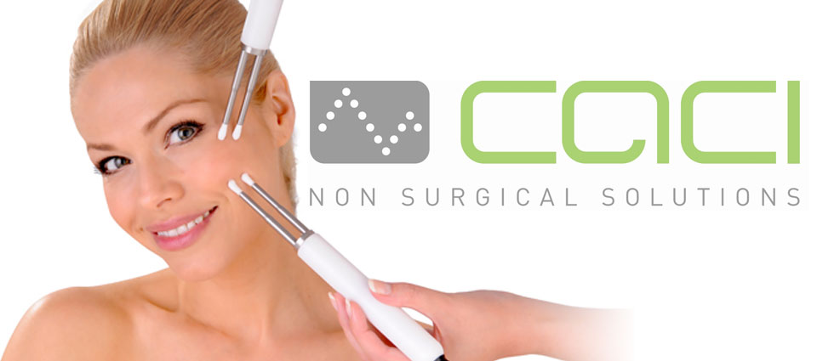

CACI ULTIMATE FACIAL TREATMENTS
The CACI (Computer Aided Cosmetology Instrument) Ultimate system has multifunctional capabilities to enable your skilled therapist to offer you the most comprehensive range of non surgical treatment options, appealing to both male and female clients of all ages combining micro-current, crystal free orbital microdermabrasion and LED light therapy.

Micro-current offers dramatic facial lifting and toning; Orbital microdermabrasion provides superficial or deep exfoliation, LED light therapy treats acne, blemishes and inflammation and combined with the wrinkle comb plumps out and softens lines, wrinkles and stretch marks. The hydratone mask provides instant skin hydration and firming.

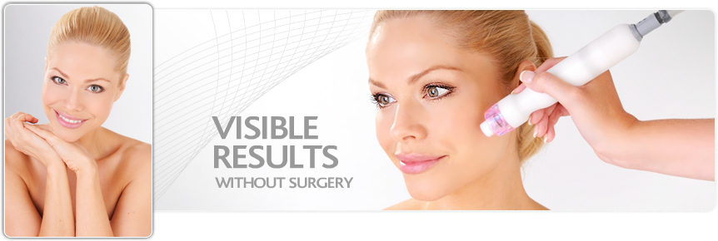

CACI Ultimate Non-Surgical Facial Toning £70
The Ultimate Non-Surgical Facial uses a combination of microcurrent, orbital microdermabrasion and LED light therapy to create an innovative treatment that revitalises the skin and tightens & tones the facial muscles.
Orbital microdermabrasion is used to gently cleanse and exfoliate leaving a brighter, smoother complexion. Microcurrent impulses will then lift and tone the face and neck, followed by CACI's unique Wrinkle Comb to target fine lines and wrinkles. The hydro mask is then applied to soothe and calm with a lymphatic drainage massage giving the face a remarkably softer, radiant and more youthful appearance.

ULTIMATE INITIAL COURSE of 5 Ultimate Deluxe Treatments & 7 Original Treatments £562 (includes 2 free treatments saving £117)
ULTIMATE MAINTENANCE COURSE of 12 £700 (includes 2 free treatments save £140)

CACI Signature Non-Surgical Facial Toning £49.00  The CACI Signature Non-Surgical Facial Toning has been developed to lift and tone the muscles of the face and neck.  This is an advanced non-invasive facial, with over twenty years medical research behind it. Microcurrent impulses will lift and tone the face and neck muscles, whilst improving skin elasticity and reducing the appearance of fine lines and wrinkles. This gives the skin a more youthful, fresh appearance and glow.  A course of 10 treatments is recommended - 2-3 treatments per week.  CACI SIGNATURE TREATMENT COURSE OF 12 £490 (2 FREE –SAVE £98.00) | £48.00
CACI Acne Treatment
Ideal treatment to target acne prone skin. £43
This soothing treatment uses blue and red light therapy (renowned for their anti-bacterial and anti-inflammatory healing properties) combined with the Hydro Gel Mask to soothe and calm, as well as reduce redness and irritation. A course of treatments is recommended dependent on condition.
CACI Orbital Microdermabrasion Treatment  Orbital microdermabrasion with LED light therapy is combined with CACI's Hydro Mask for a healthy, glowing complexion.  Controlled orbital microdermabrasion is used to deeply cleanse and exfoliate the skin, combined with LED light therapy for tissue repair and healing. The Hydro Mask is then applied to soothe and calm with a lymphatic drainage massage, giving the face a remarkably softer, radiant and more youthful appearance. A course of 10 treatments is recommended - 1 treatment per week. | £40.00
CACI Jowl Treatment £25
The CACI Jowl Lift specifically targets muscle laxity around the jawline using quad probe applicators designed to double the lifting action of the CACI treatment system. Ideal as an add on to the CACI Signature Facial to lift and firm the muscles and redefine facial contours to give a firmer more toned appearance. A course of 10 treatments is recommended - 2-3 treatments per week.

CACI JOWL TREATMENT COURSE OF 12 £250 (2 FREE- SAVE £50)

N.B all courses must be paid in advance and taken within 12 months
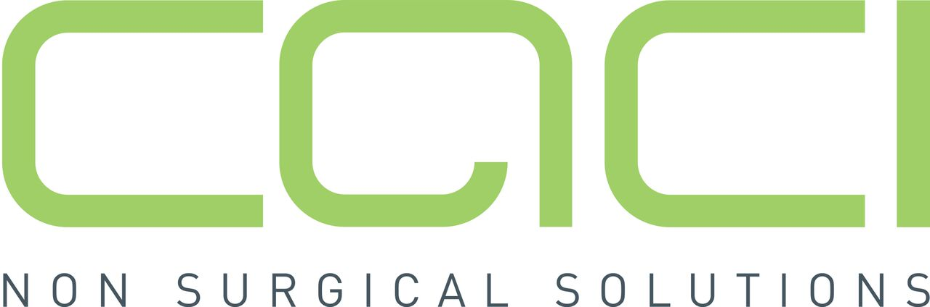

CACI - FAQS

What is microcurrent?
Microcurrent therapy delivers tiny electrical impulses that mirror
the body’s own natural bioelectrical field. Microcurrent stimulation
helps to re-educate the muscles and can lift, firm and tone.
Microcurrent in aesthetics is commonly described as “facial
toning” or “non-surgical face lifting” due to the dramatic lifting
effect that it has on facial muscles and contours.

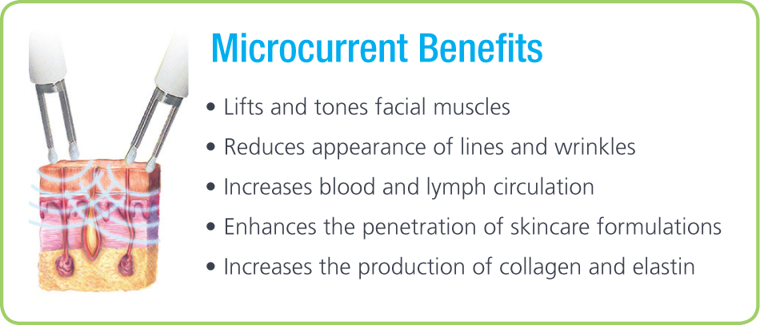

What does microcurrent feel like?
Microcurrent treatment is virtually sub-sensory with just a slight
tingling sensation. Customers often describe it as an energised or
warm sensation on the skin and is virtually painless.

Is microcurrent safe?
Yes. Microcurrent therapy was originally developed as a medical
application to treat facial palsy and restore muscle tone by
applying tiny microcurrent impulses to the affected muscles.
Today this proven technology is now available in thousands of
aesthetic clinics worldwide as a painless cosmetic treatment.

How many treatments should I have?
Although a remarkable difference is seen after the first treatment,
the benefits of microcurrent are cumulative and typically a course
of 10-15 treatments will be required for optimum results.
When you purchase 10 treatments receive TWO FOR FREE!

What happens after I have finished a course of treatments?
After a course of CACI Non-Surgical Facial Toning treatments
you will see real improvements in how your skin looks and feels.
Your facial contours will look lifted and toned with a fresher,
more youthful appearance. A monthly top up treatment is then
recommended to maintain results.

What happens if I stop treatments?
It’s just like going to the gym for a body workout. If you stop,
the results will gradually diminish and your facial muscles may
eventually return to how they were before treatments commenced.

Will there be any recovery or downtime after my treatment?
No. CACI treatments are non-invasive and gentle on the skin so
there is no interruption to your lifestyle.

What is orbital microdermabrasion?
Our unique crystal-free microdermabrasion offers a precise and
controlled skin exfoliation. The procedure diminishes fine lines and
imperfections to achieve a smoother, more radiant complexion.
The treatment combines orbital skin resurfacing, which is unique
in the market, with LED light therapy to provide a gentle peel for
sensitive skin or a deeper peel for thicker, sun damaged skin.

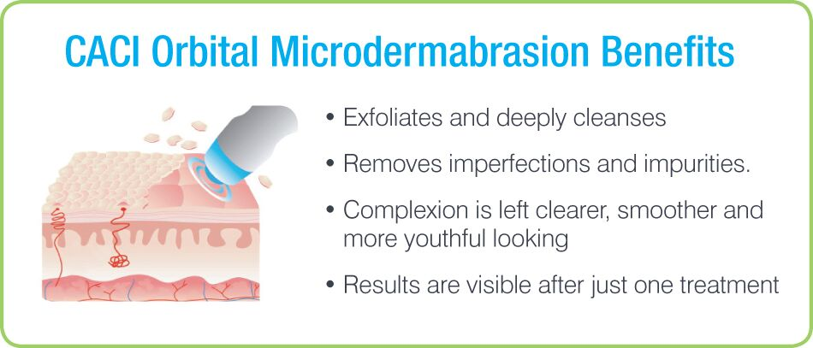

What does orbital microdermabrasion feel like?
The treatment doesn’t hurt at all. We use a ‘no dragging’ and
‘no pulling’ technique on the skin and simultaneous vibrations to
make the treatment very comfortable.

What is LED Light Therapy?
LED Light Therapy utilises the therapeutic properties of red light
and blue light to calm the skin, neutralise bacteria and reduce
redness in order to help tackle acne, blemishes and scar tissue.
Blue light calms the skin and destroys skin bacteria and red light
stimulates new tissue growth and cellular regeneration. Combined
red and blue light is extremely effective in the treatment of acne
and blemishes.

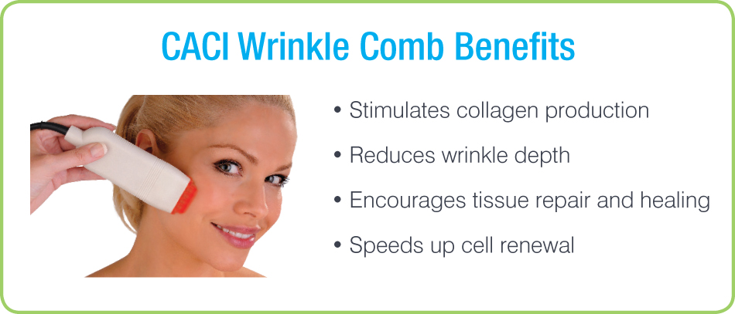

In what circumstances is treatment not advised?
Treatment is not advised if you have any of the following conditions:
All forms of cancer, pregnancy, epilepsy, diabetes, heart condition/
cardiac pacemaker, thrombosis, facial implants (if treating face),
skin disease (avoid area), skin lesions, recent surgery (performed
within the last 6 months), Areas being treated with Botox®(wait 3
months) or dermal fillers (wait 2 weeks) should be avoided. Note:
Anti-depressants, high blood pressure and other muscle relaxants
may reduce the effectiveness of the treatment.

Please note:
If you are taking any medication or have an existing medical condition or concern not listed above, please consult with your doctor first.

BODY AND HOLISTIC TREATMENTS

Aromatherapy Back, Neck and Shoulder Massage………… ……….£28.00
Focusing on your upper body, this deep muscular massage will help relieve tense muscles and stimulate circulation, resulting in complete mental and physical relaxation.
Aromatherapy Body Massage………………………………………………£42
A wonderful treatment to relax your whole body. This massage will reach the deeply stressed areas of your muscles, working out tensions and making you completely relaxed.
Reflexology…………………………………………………………………….……..£42
This ancient therapy treats the whole foot to relax and help to heal the whole body. This responsive therapy is particularly helpful for back pain, P.M.T and stress.
Hopi Ear Candles…………………………………………………………………..…..£30
This gentle treatment is the perfect way to clear congestion from the ear and sinus area. Commencing with a relaxing pressure point massage to the face, helping the release of blockages and pressure, the candles are then placed in the ear one at a tie. A beautifully relaxing therapy.
Indian Head Massage……………………………………………………………………£30
An ancient art based on a traditional system of medicine called Ayurveda, which has been practised in India for over 3000 years. By gently stimulating circulation and easing muscle tension, this treatment can help ease headaches and eye strain, whilst promoting a sensation of calm

Hot stones massage
Full Body…………………£60 Back of body…………£40
An exceptional treatment using smooth hot stones in conjunction with calming aromatherapy oils to ease the stress and tension from your body. The heat radiated from the stones give an amazing degree of comfort and relaxation. Amazing!

Lava Shell Massage
An absolutely stunning experience, the recycled tiger clam shells stay warm for the duration of your treatment, providing a seamless massage to transport your mind to the south seas….!
Full Body………………..£65 Back & Back of Legs £45

CACI QUANTUM ECM BODY TREATMENT
This powerful massage tackles cellulite, fluid retention and stubborn fatty areas on the legs and buttocks. It contours and firms underlying muscles, leaving skin smoother and firmer.
For best results a course is recommended.
Single treatment £25.00
Course of 12 £250.00
N.B courses must be paid in advance and taken within 12 months.
HANDS AND FEET

All your nail nightmares are over! No more chipping or flaking, no drying time, Gel Varnish strengthens without damage! Just a fabulous high shine which lasts for 14 days. The answer to perfect varnish without resorting to nail enhancements.
Geleration Gel Manicure …………………………..£28.00
Geleration Gel Pedicure ……………………………£33.50
Fortnightly soak-off & Mini manicure (free with reapplication)…………..£10.50

Jessica Classic Manicure ………………………………………….£21.50
A great treatment for hands using the unique Jessica Cultivation System from the U.S.A. Includes shaping, cuticle work, massage and polish, using products chosen for your nail type.

Jessica Luxury Thermal Manicure……………………………£28.50
A wonderful treatment for dry, hardworking hands, all the same benefits of the classic treatment, but with the addition of luxurious hot mitts.

Mulberry Spa Pedicure…………………………………………..£28
Warm whirlpool bath, nails are shaped, cuticles minimised, legs and feet are exfoliated.. To finish, a lovely hydrating massage and nail polish application will leave your feet looking and feeling beautifully groomed.

Mulberry Luxury Thermal Spa Pedicure…………………………£32
All the wonderful benefits of the spa pedicure, with the added luxury of warm booties and a special stimulating, deeply hydrating foot masque.

Classic French Finish
With any of the above manicure or pedicure services……………….add £2.50
Please remember flip flops or open toed sandals for any pedicure service

Nail Enhancements
Long, strong nails instantly! Great for nail biters, anyone who has trouble growing their nails, or indeed just because you NEED beautiful nails- permanently! Mulberry used the world renowned CND nail enhancement system.
Full set……………………………………………..£42
Rebalancing from……………………………….…£28
Additional gel finish ……………………………….£3

SIENNA X SUNLESS TANNING
Get a gorgeous glow, which lasts for days! Pale skin? Don’t worry! With several depths of colour available, you choose how deep your tan is!
Single treatment £20
Buy 4 get 1 free £80 (save £20)
N.B course must be paid in advance and taken within 6 months

Make-up
Mulberry are proud to use Jane Iredale Mineral Make up
Day or Night…………………………………….………………£35
Bridal
Bride (inc trial)…………………………………………….……£80
Additional bridesmaids, mother-each…………………………£25
Home visiting service available…………………………………POA
Wedding treatment packages available

Gift vouchers
Our gift vouchers are available for any value or salon treatment.
Vouchers are non-refundable & must be presented before treatment. If you need inspiration, check our package ideas.
Call to purchase by phone!

OPENING HOURS
Tuesday-Thursday 9.00am-8.00pm
Friday 9.00am-6pm
Saturday 9am-4pm
Appointments always available before and after these times by prior arrangement.

Tel 01283 704694
www.mulberrybeauty.co.uk
find us on facebook facebook logo

please note, we require 24 hours notice of cancellation in order that we may reallocate the appointment, otherwise a charge of 50% may be incurred.

